**Seeing Diamonds: Statistical Graphics in the Introductory Course**

David Kahle

Baylor University

**Key Words:** Data visualization, big data, introductory statistics

**Abstract**

Data visualization and exploratory data analysis are prime places in which individuals of all walks of life encounter statistics on a daily basis. This is especially true with the advent of “big data”, where complex relationships are the norm and out-of-the-box elementary statistical procedures must be applied with great care. These realizations rightly call us, as statistics educators, to redouble our efforts in teaching these most basic statistical methodologies in the introductory course. In this article we show how Wickham’s diamonds dataset can be used to illustrate a wide variety of statistical concepts and graphics, including big data, in the introductory course.

**1. Introduction**

*Modern data graphics can do much more than simply substitute for small statistical tables. At their best,* ***graphics are instruments for reasoning*** *about quantitative information. Often the most effective way to describe, explore, and summarize a set of numbers­–even a very large set–is to look at pictures of those numbers.*

Edward Tufte (Tufte 2001)

Emphasis added.

The first session of every introductory statistics class I teach begins with a question: “What is statistics?” It’s a simple question with a wide array of answers still being written. After polling the audience for thoughts, I proceed to give my own thoughts on the subject, starting with a real conversation I had a few years back at a holiday party. As all such events include meeting new people, I found myself in several first-encounter conversations that night, one being particularly memorable. After being asked the customary “What do you do?” and responding that I am a statistician, my acquaintance’s eyes narrowed and head tilted slightly, nodding gently. “Oh, so… you watch a lot of baseball?” *Better than “Oh, I hated that class in college,” I thought.* “Yes,” I act out my response to the students with a sardonic tone and mischievous smile, “I watch a *lot* of baseball.” I go on to explain that statistics is, of course, more than baseball, more than averages, more than, well, *statistics*. It requires a kind of mindset, part art, part science, and is deeply concerned with the analysis of data.

So if statistics is so concerned with data, what is data? This is, in some ways, an incredibly difficult question to answer, and definitions can vary dependent on the context in which the word is used. For example, data to a computer programmer may mean settings for a particular program. In the introductory statistics course, the term is typically reduced to spreadsheet-type data whose rows, of which there are *n*, represent subject or objects and whose columns, of which there are *p*, represent variables or measurements on those subjects/objects.

Good datasets tell stories. Great datasets tell stories with morals that exemplify aspects of the analytic process itself that generalize to all datasets, warning of pitfalls or illustrating a certain technique. Used properly, they can provide students with a distilled form of years of experience analyzing data, understanding variability and nuances of association. In this article I consider Wickham’s diamonds dataset, which I consider to be a great dataset, not just for its aid in illustrating the statistical process of asking questions and seeking answers, but while in so doing introducing the students to fundamental concepts: data types,

Stories are memorable. They can help contextualize otherwise mundane bits of information into distinctive mnemonics that are not only hard to forget but can color our understanding of the things themselves. They are, in a sense, empirical in nature and broadly accessible to general audiences. It is for this reason that stories can, and perhaps even should, be used extensively in the introductory statistics course. Of course, the adage that “the plural of anecdote is not data” remains in force. Rather, the idea is that, when careful we can use stories to communicate experiences to students in an accelerated fashion that are generalizable to overarching statistical lessons.

This is particularly true of statistical graphics, as visuals naturally lend themselves to stereotypes (e.g. histogram shapes).

In this article I consider various aspects of Wickham’s diamonds dataset. Described in detail in the next section, the dataset comes as part of the **ggplot2** package in R (Wickham 2009). It is therefore accessible via the following code in R:

R> install.packages(“ggplot2”)

R> library(ggplot2)

R> diamonds

Additionally, the dataset can be accessed from <INSERT URL HERE>. The code used to generate the graphics in this article can be found at <INSERT GITHUB README PAGE HERE>.

The diamonds dataset is a great dataset to use to introduce statistical graphics for several reasons. First, the dataset has variables of differing types (see Section 2), and therefore can be used to illustrate how statistical graphics must change based on type. Second, virtually all students have some familiarity with diamonds, at very least the basics: their size is measured in carats, and they become more expensive as they get larger. This knowledge leads to interesting questions when trying to understand various graphics. Third, the dataset is fairly large. At over fifty thousand diamonds, raw-data graphics easily show pronounced overplotting effects, which can be used to motivate ideas such as jittering and binning/summarizing. Lastly, and importantly, in my experience the topic of diamonds resonates with both male and female college students.

**2. Wickham’s Diamonds Dataset**

The dataset consists of *p =* 10 measurements (variables) on *n =* 53,940 individual round-cut, unset diamonds that were collected observationally. To get a sense of the dataset, the first twenty such diamonds can be seen in Figure 1.

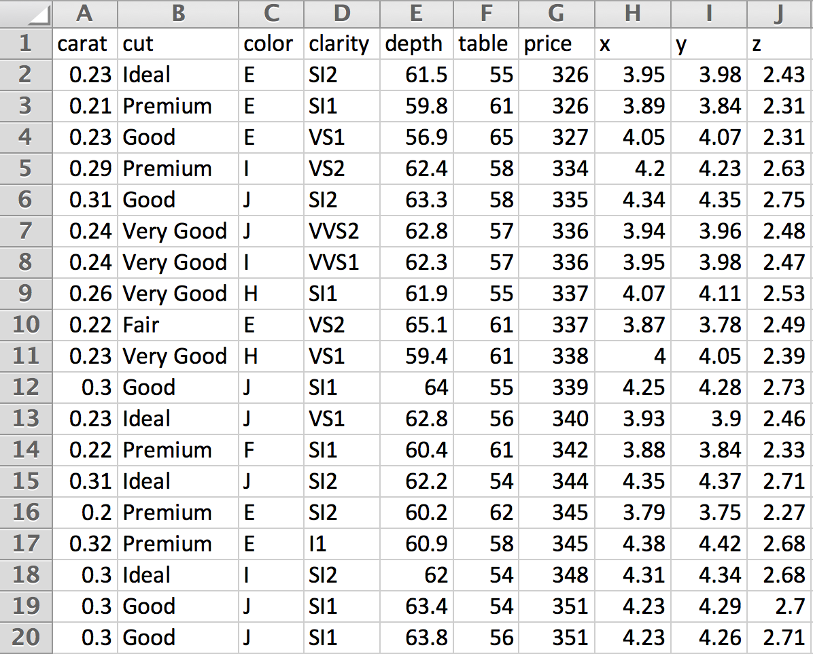

Figure 1. The first twenty rows of the diamonds dataset.

Below are details on each of the measurements. The scales of the diamonds are those of the Gemological Institute of America (GIA), which certifies diamonds for a cost. The GIA sets scales such as those used for color and clarity (as well as other qualities not in the dataset, such as fluorescence. To keep the scale consistent, the diamonds are graded by comparison with master stones in controlled settings.

*Helpful Hint: Using the diamonds dataset can be a nice to introduce variable types and scales. While not all variable types are present (there is no count variable, for example), topics such as ordinal variables and the continuous vs. discrete divide can be addressed. To supplement those missing, you may consider giving as examples the shape the diamond is cut into as a categorical variable (all those in the dataset are round) and the number of imperfections in the diamonds as a count (quantitative discrete) variable.*

*Teaching Gem: The discrete/continuous distinction can sometimes be challenging for students. Without getting too technical, useful device to explain the divide is the following: if the sample space is finite or countably infinite, the experiment or variable is said to be discrete, if it is uncountably infinite, it is said to be continuous – this will help in explaining (for example) why the Poisson distribution is a discrete distribution even though its sample space is infinitely large. However, most students at the introductory level have no exposure to orders of infinity. To overcome this, and introduce students to some beautiful mathematics in the process, have them watch the seven minute TED-Ed talk given by Dennis Wildfogel available online at the url* [*https://www.youtube.com/watch?v=UPA3bwVVzGI*](https://www.youtube.com/watch?v=UPA3bwVVzGI)*. Most students find the talk fascinating, and it’s rewarding knowing that you’re educating students in ways outside of statistics as well. This is particularly true for liberal arts educators.*

carat. The size of diamonds is typically communicated in carats, the carat being a unit of mass equal to 200mg.

cut. The sparkle of a diamond is due to the extent to which light, entering the top of the diamond, is refracted around inside the diamond and exits the top. The phenomenon where light exits the bottom of the diamond is known as leakage; leakage is considered a bad quality because it diminishes the light leaving the top of the diamond and, therefore, the sparkle of the diamond. The amount of leakage of a diamond depends on the angles at which the diamonds are cut. Jewelry companies often have patents on specific geometries with which their diamonds are cut: a certain number of facets, exact angles at which facets meet, etc. cut refers to the quality with which the diamond cutter was able to achieve those specifications. It is rated on the five point scale Fair, Good, Very Good, Premium, and Ideal.

color. When diamonds are found in nature they typically range from being white, which is no color at all, to a slightly yellowish tint. This is due to imperfections on the molecular level, some of the carbon atoms of the crystal lattice being substituted with other elements. At slight to moderate levels, this is considered unfavorable; however, diamonds with a strong hue to them such as yellow, red, or blue, are much more rare, and consequently more valuable. They are termed “fancy diamonds.” There are no fancy diamonds in the diamonds dataset, so that all the diamonds in the dataset range from colorless to a shade of yellow. The scale, however, is quite confusing; it ranges from D to Z, with D through E being termed “colorless” and G through J “near colorless.” Untrained observers can typically detect a yellowish hue when asked around J, but if the diamond is set in a yellow-gold band, it can be harder to detect.

clarity. Perfect diamonds are clear; however, all natural diamonds (those formed through normal geological processes) exhibit imperfections, at least at the microscopic level. In fact, synthetic diamonds, which are much less expensive, can be detected by their lack of imperfections. These imperfections take various forms, but are typically either black specks, which are graphite, or bubbles – pockets of air. Unfortunately, the scale for clarity is even more confusing than that of color. The best is Flawless, followed by Internally Flawless, Very Very Slightly Included with tiers of 1 (better) and 2, Very Slightly Included 1 and 2, Slightly Included 1 and 2, and Included 1, 2, and 3. The diamonds dataset contains no Flawless diamonds. The rest are abbreviated IF, VVS1, VVS2, VS1, VS2, SI1, SI2, and I1 (diamonds also contains no Included 2 or 3 diamonds).

x, y, z, table and depth. Diamond dimensions are provided according to Figure 2. What delineates x from y in terms of physical dimensions is not clear, but as it is not relevant for any problems, it can be disregarded.

price. The assessed price of the diamond, US Dollars.

*Teaching Point: Is price a discrete or continuous variable? This actually gets away from the previously discussed technical details, as most statisticians would call this price variable continuous. Why? (Answer: Practically speaking, there are over 10,000 unique numerical price observations. Statistics is both an art and a science. The artistic component of statistics looks at the price data and says that, while it’s true that the sample space is finite, it’s quantitative and* large*; moreover, the differences of the outcomes are on the order of 1, which is very small compared to the dispersion of the data. Put another way, if we were to consider the units of price as thousands of dollars and then look at the raw numbers out of order, we would be hard-pressed to consider them as discrete as opposed to simply rounded continuous measurements.)*

Figure 2. Diamond variables x, y, z, table and depth.

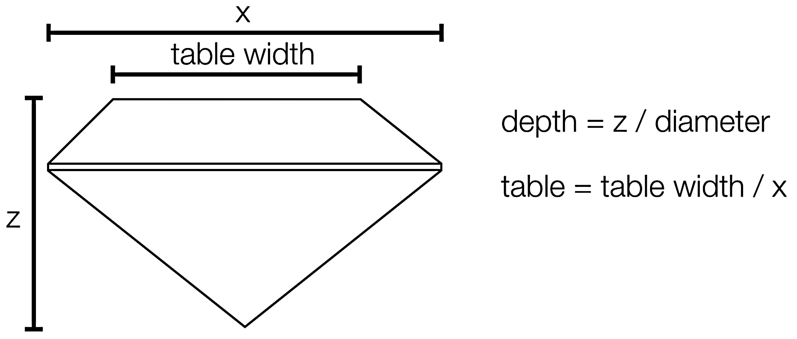

**2.1 What’s “big data”?**

Although the term “big data” is currently in fashion, the term is notoriously difficult to precisely define; however, by virtually no current definition would the dataset be considered “big data.” This may come as a surprise to students, since printing out the Excel spreadsheet using 12 point font would require well over two reams of paper!

While there is no real standard for what should be called “big data”, there is a feeling that big data itself comes in scales dependent on kinds of analyses of interest. For example,

*Potential Teaching Digression: One major current problem in statistics is the so-called p > n problem. For the diamonds dataset, clearly n >> p; however, now can be a nice place to introduce the p > n problem. This is particularly true when teaching pre-health students where such problems are routinely encountered. Gene association problems provide an accessible example: the variables (columns) in question are gene expression levels, of which there may be tens or even hundreds of thousands, and the subjects (rows) represent individual patients.*

**3. Understanding the Variables Individually (Marginally)**

Every statistical analysis should begin with descriptive considerations of the data at hand, and, to the extent possible, visualization techniques should be included in these considerations. The comparatively more sophisticated inferential techniques learned later in the introductory course should only proceed *after* preliminary exploratory analyses, and for several reasons. First, if present, data contamination can lead to false conclusions.

*Teaching Tip: Early discussions of robustness in terms of numerical descriptives (particularly the sample mean and sample median) can pay huge dividends in understanding later in the course when explaining why the t-test can be corrupted by outliers.*

Second, violated assumptions in general can invalidate virtually any statistical procedure. Third, many problems don’t require inferential procedures because the conclusion is obvious from the data. Sure, the association between gender and breast cancer is statistically significant. But, looking at the data, did you really need to do the hypothesis test? The list of reasons to emphasize inferential procedures after descriptive ones goes on and on.

In this section we describe statistical graphics for a single variable.

*Teaching Tip: Students are almost always familiar with graphics for discrete variables, don’t let them check out! Understanding exactly what is going on in discrete graphics is key to understanding continuous ones, such as the histogram, and beyond!*

**3.1 Discrete Variables**

Two of the most fundamental concepts in statistics are frequency distributions and relative frequency distributions. Given a discrete variable, the frequency distribution of the variable is simply the counts of the number of times each unique observation (level) was observed; the relative frequency distribution divides those numbers by the number of observations to provide the proportion of samples of a given level. The cut variable provides a good example as it has few levels.

|  |  |  |
| --- | --- | --- |
| **Cut level** | **Freq.** | **Rel. Freq.** |
| Fair | 1,610 | .030 |
| Good | 4,906 | .091 |
| Very Good | 12,082 | .224 |
| Premium | 13,791 | .256 |
| Ideal | 21,551 | .399 |

Table . Frequency and relative frequency distributions of cut.

The standard way to visualize these distributions is as bar charts or pie charts. For bar charts, we simply draw rectangles with base at the *x*-axis and whose height corresponds to the frequency of the level. Since the variable is ordinal, the order should be maintained in the graphic. For pie charts, a circle is drawn and wedges are depicted with angles equal to the relative frequencies times 360°. These can be seen in **Figure 3**.



**Figure 3.** Bar and pie charts for cut.

Observations concerning bar and pie charts:

1. The use of the frequency distribution to construct the axis is arbitrary. Had we constructed the chart using relative frequency, the shape of the chart would look precisely the same. This fact is useful later on when discussing probability density functions, which use the density scaling. (Note that some software, such as JMP, call “Frequency” “Count” and “Relative frequency” “Probability”.)
2. For a proper understanding of bar charts, the *x*-axis must be displayed at *y* = 0. Failure to do this can cause significant visual misrepresentation.
3. The width of the rectangles in the bar chart is arbitrary, as are the gaps between the bars. They should, however, remain equal in width as they do not represent something that varies between the levels.
4. Rotations of the pie chart do not change its interpretation.

In general, bar charts are vastly preferable to pie charts as human ability to perceive angles is poor, especially across distances, for instance centered on cities on a map (Tufte 2001).

Considering the dataset at hand, it is interesting to note that Ideal cut diamonds are by a good margin the most prevalent type, and that good and fair diamonds are poor.

**3.2 Continuous Variables**

There are two reasonable continuous variables in the dataset to consider, price and carat. We choose to investigate carat, the findings with price are similar.

**3.1.1 Scatterplots.** One of the most natural ways to visualize a collection of continuous measurements is simply to plot them on a real number line; this is referred to as a (1d-) scatterplot. For clarity, in this example we select 50 such diamonds; which 50 is clear from the code. A typical scatterplot is then pictured in Figure 4.



Figure 4. One-dimensional scatterplot of 50 diamonds’ carat weights.

*Teaching Tip: Ask your students what might be bad about this graphic, and how to fix it.*

The chief problem with the scatterplot in Figure 4 is that points are stacked on top of each other, making the precise number of points ambiguous. This effect is known as *overplotting*; it is the visual confusion of a graphic due to plotting too much data. In this case “too much data” is simply 50 observations.

There are various ways to try to fix scatterplots to reduce the effect of overplotting. Three, in particular, are commonly employed.

1. *Jittering*. In Figure 4 the *y*-axis is not used, so it has no interpretation. One mechanism used to reduce overplotting is to generate random *y* values for the data, typically from a uniform distribution. An example of jittering is provided in Figure 5. Jittering can be a very effective way to reduce overplotting, but it has its limitations.



Figure 5. Jittering in a 1d scatterplot.

1. *Alpha blending.* Another strategy is to make the individual points semi-transparent. Places where points coincide spatially then will appear darker. An example of alpha blending is provided in **Figure 6**. Alpha blending is typically done in a manner that allows the statistician to know how many points need to stack to make the visual opaque. In **Figure 6**, this number is three.



**Figure 6.** Alpha blending and jittering in a 1d scatterplot.

1. *Resizing.* Another common adjustment is to reduce the size of the points themselves. Like alpha blending, resizing can be very effective; however, the more one shrinks the points the harder the points are to see. Thus, resizing (and alpha blending for that matter) ought to be used judiciously – while they may help the overplotted regions, they hurt the more isolated regions. A final version of Figure 4 is presented in Figure 7.



Figure 7. Point resizing, alpha blending, and jittering in the 1d scatterplot.

Unfortunately, when all fifty thousand diamonds are plotted, not even the combination of the three adjustments can present us with a good graphic. Figure 8 depicts all 53,940 diamonds with an alpha blending that requires 100 points for 100% opacity. However, the tradeoff becomes painfully apparent: while the overplotting persists in regions of extreme overplotting, the more isolated points grow nearly invisible. Clearly an alternative strategy would be preferable.

*Teaching Tip: Try having your students invent the histogram themselves. Pick out a few dozen diamonds, and ask them to invent a good visual. If they go by analogy the discrete data, they will make a frequency distribution and then a bar chart. But for most few-dozen datasets, this is very uninteresting – the frequency of each observation is 1 and the resulting bar chart is a bunch of useless spikes with height one. Use this to motivate the idea of binning.*

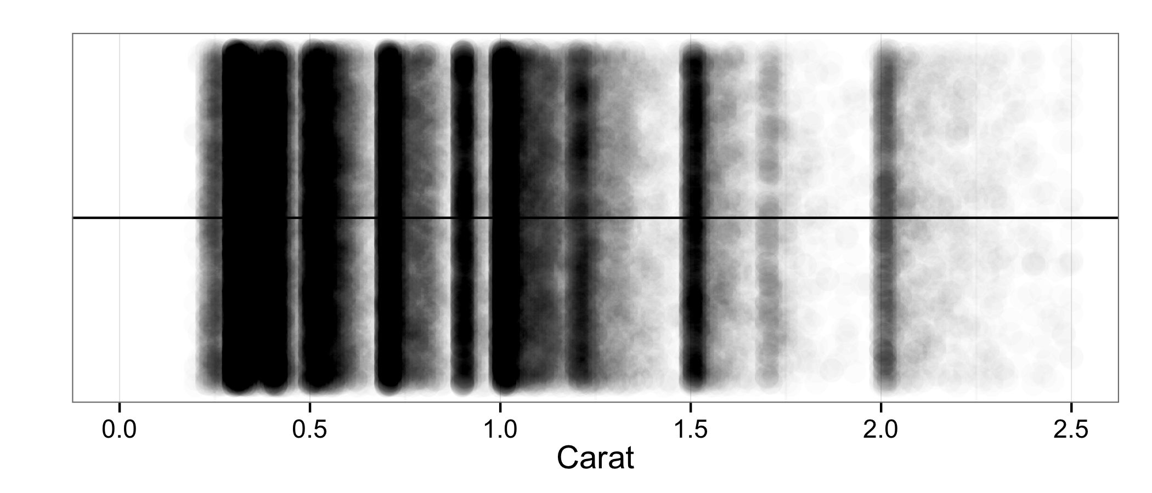

Figure 8. 1d scatterplot of all the diamonds' carat weights.

**3.1.2 Histograms.**

Moving away from scatterplots, a tempting idea is to turn to the idea that was successful with discrete data: construct a frequency distribution and then a bar chart based on the frequency distribution. However, that idea fails because with continuous data, the probability of ties is zero. Consequently, each observation will only be observed once, making the bar chart useless for practical purposes.

The idea of the histogram is to partition the range of the data into intervals called “bins,” count the number of observations falling into each bin, and use these frequencies to create a kind of bar chart. This bar chart, however, has rectangles whose widths and placement are meaningful.

The most important factor when constructing a histogram is the bin width used. If the width is too big, all the data clumps together in a small number of bins, which is never useful. If it is too small, then each bin will capture only a single observation, and you’re back in the bar chart situation. Histograms with bin widths 2, .17, and .01 are displayed in Figure 9.







Figure 9. Histograms of varying bin widths.

Clearly the first histogram has bin widths that are far too large, there is no shape to be seen. However, the medial bin width setting here is also not the best. Looking carefully at the third histogram, we see that there is in fact a great deal of structure: a repeating pattern of peaks followed by a trailing off. Why could this be?

When diamonds are harvested from the earth they are far from pristine products; they look somewhat like rock salt embedded in black rock. To make a presentable gem out of them, therefore, the black rock must be cut away and the diamond must be cut into a desired shape. Doing this requires sacrificing at least some of the diamond, so jewelers have developed very sophisticated techniques (computerized, even) to find, for a given rough diamond, the geometry that minimizes the loss of diamond and the orientation of that geometry in the stone. This maximizes the mass of the marketable diamond, and consequently its value. That is to say, when presented with a rough diamond, a jeweler has some flexibility in how she decides to cut it. Since the biggest determinant of a diamond’s cost is its mass, the cutter may be tempted to forgo angles ideal for minimizing leakage if in return they can produce a larger diamond.

The average price of the diamonds whose carat mass falls between .99 and 1.00 is $4,406, whereas the average of those that fall between 1.00 and 1.01 is $5,241, a substantial difference.[1] Taking this into consideration, a reasonable explanation for the peaks is that when jewelers find a diamond, they do their best to make sure the diamond hits more valuable size thresholds: .5 carat, .75 carat, .90 carat (the biggest round number before the big jump), 1 carat, and so on.

Another general rule can be learned: as *n* increases, the binwidth of the “best” histogram decreases. This agrees with the various rules of thumb about optimal histogram bin width but requires no mathematics. It can also be used as a motivator for probability density functions later in the course.

*Teaching Tip: Teaching distribution shapes (bell, uniform, skewed, etc.) is low-hanging fruit after teaching distributions.*

**3.1.3 Kernel Density Estimators.** In practice, it is very common to see another kind of visualization for one-dimensional continuous data: the kernel density estimator (KDE). Precise definitions and formulas aside, KDEs are easily motivated and understood using the histograms above.

Consider the “best” histogram presented in Figure 9. Between peaks, the histogram was described as “trailing off.” It is very reasonable to believe that the differences between neighboring boxes is not actually present in real diamonds. While arguments can easily be made as to why diamonds with a carat weight of 1 are more common than those of .99, the argument cannot be made in general: discontinuities such as those present in the histogram are almost certainly mere artifacts of the graphic itself, not the underlying population of diamonds. There, it is thought, the graphic should present a smooth curve, not a disjointed series of boxes.

One easy way to motivate getting such a curve is to take a small collection of diamonds, like the 50 that were used in the scatterplot example, and put little bell curves over them – normal densities with a common standard deviation centered at the observed values (students typically have not gotten to the normal distribution at this point in the course, so the “bell curve” vernacular can be helpful). Then to get a kind of smooth histogram, we can simply add up the height of the bell curves to get a kind of smooth histogram, the KDE. This is depicted in Figure 10, along with a histogram of the same fifty points. Note that the interpretation of the *y*-axis is now no longer frequency, but density.





One can make KDEs in several ways. As a first observation, note that the selection of the width (standard deviation) of the bell curves was arbitrary. This parameter, called the bandwidth, is the KDE analogue of the histogram bin width and functions similarly: too big a bandwidth swamps the data, and too small a bandwidth creates isolated spikes. The interactive distributions module presented by Kahle (2014), available at <http://www.baylor.edu/statistics/disttool>, can be used to illustrate this problem interactively. More generally, one can use a different shape other than the bell curve. These shapes, functions really, are called kernels (hence the kernel density estimator label). There are several kernels used in practice, from triangles to half circles; many can be seen in the distributions model referenced above.

Figure 10. A kernel density estimator (KDE) and histogram on the data in Figure 4.

**4. Analyzing Two Variables Together**

Rarely do statistical analyses only involve one variable. Instead, analysts are almost always interested in associations (interactions) between two or more variables at once. In the last section it was assumed that as a diamond gets larger, it gets more expensive. Is that so? How can we explore that idea? In this section we discuss visualizing two variables simultaneously. In the two-dimensional case, however, it helps to work backwards from continuous to discrete, so we start with the easiest case of two continuous variables.

**4.1 Continuous-Continuous Graphics**

**4.1.1 2d Scatterplots.** Perhaps the most obvious question to consider with this dataset is the relationship between the size of a diamond and its cost. The expectation is, of course, that as diamonds get larger, they tend to get more expensive. The most basic way to visualize this is by means of a 2d scatterplot, as in Figure 11.

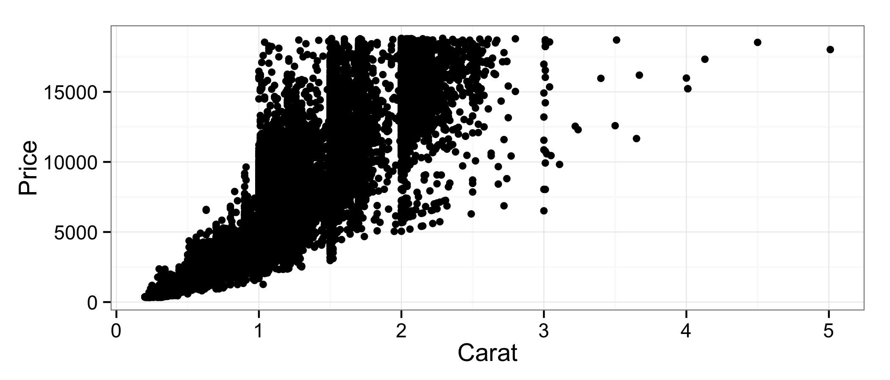

Figure 11. The 2d scatterplot.

As with previous scatterplots, however, significant overplotting swamps the graphic. While the general trend seems to hold–bigger implies pricier–it is unclear how pronounced that relationship really is, since the graphic is predominantly ink.

The standard tricks can help to some extent. When jittering in two dimensions, each point is moved randomly in a rectangle tailored to the granularity of the data in both dimensions, the smallest distance between any two points in that dimension. Since the resolution of the diamonds dataset is very high (distances are very small), jittering is not very helpful. Alpha blending and shrinking help us understand things a little bit better, see Figure 12.

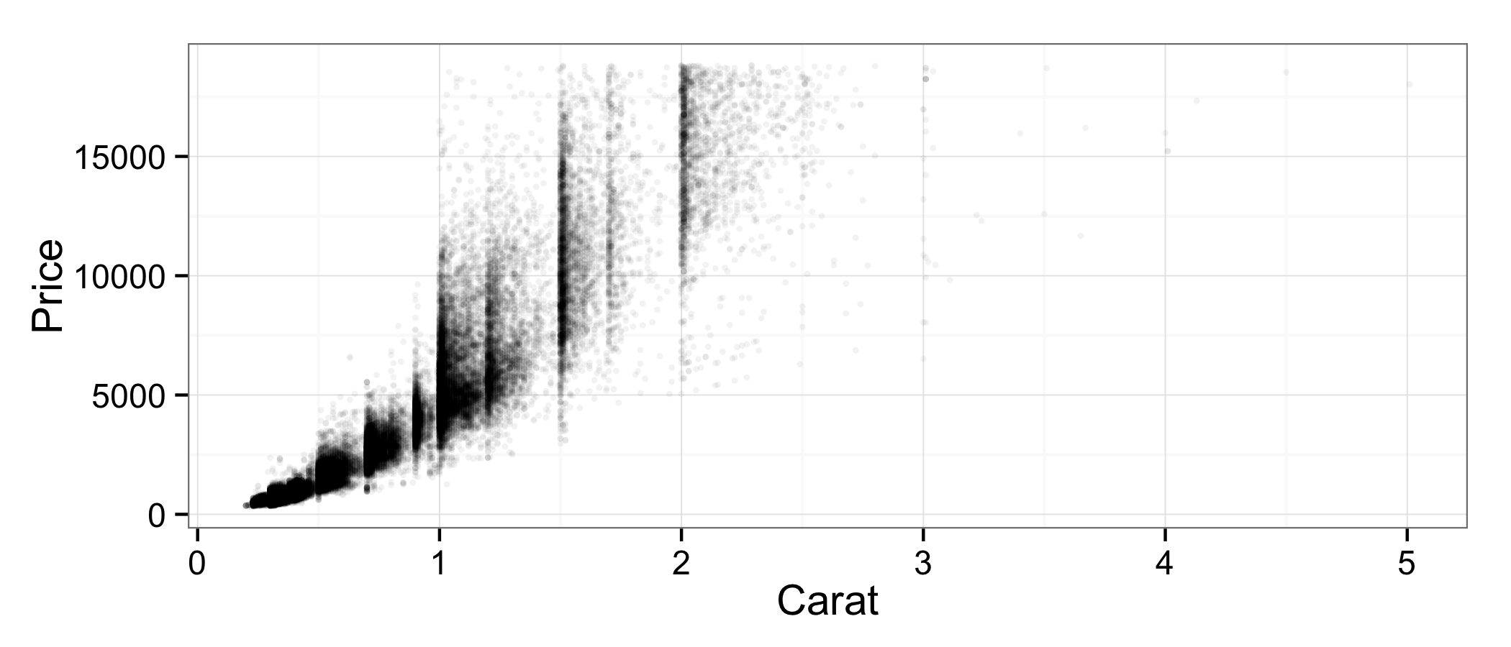Figure 12 is clearly better than Figure 11; however, the overplotting still persists, much like with Figure 8. Don’t be thrown off by less ink–Figure 12 still exhibits significant overplotting and, like with Figure 8, more isolated points are not visible.

Figure . The 2d scatterplot with resizing and alpha blending (opaque = 20 points).

**4.1.2 2d Histograms.** As in one dimension, the real solution is to create localized summaries–in this case, to bin. In two dimensions, the most natural way to bin is to break the *x-* and *y*-axes into intervals, the products of which create bins, and the *z*-axis is used for frequency. The name here can be somewhat confusing: the 2d histogram is a 3d graphic, but this should not be surprising. The 1d histogram is a two-dimensional graphic because the calculated statistic (frequency) takes up the second dimension.

2d histograms look like cityscapes. An example using carat and price is in Figure 13.



Figure 13. The 2d histogram for carat and price.

The chief problem with three-dimensional 2d histograms is that, like all 3d graphics, they can present perspectival problems. For instance, more frequent bins eclipse part of the data in Figure 13: it is unclear how frequent small expensive diamonds are without rotating the graphic.

The remedy in such situations is to use other visual cues to communicate the frequency variable. This can be very easily motivated: if we consider the 2d histogram from directly above, we see an array of rectangles (the bins) whose height is difficult to see because they are “coming out” toward us. Instead of representing frequency with height, it is preferable to render a 2d histogram as a 2d array of shaded rectangles with a legend indicating the correspondence between the shadings and the frequency (such correspondences are sometimes called aesthetics, see Wickham 2009). An illustration of this process is presented in Figure 14; bins containing no observations are omitted.

Figure 14. The three-dimensional 2d histogram from above (left), and the more commonly used two-dimensional 2d histogram (right).



The two-dimensional 2d histogram seen on the right in Figure 14 is very commonly seen in practice. In it we see that the vast majority of diamonds are very small and that the trend is clearly super-linear: as diamonds get larger, not only do their prices increase, but it they increase at an increasing rate. This can be confirmed visually using a smoother, like the one in Figure 15. Describing how these smoothers are made is beyond the scope of this article and most introductory courses, but most modern statistics graphics programs such as JMP and R/**ggplot2** can create them with the click of a button or short line of code.



Figure 15. A 2d histogram with a smoother.

**4.1.3 Contour plots.** Kernel density estimators are also used in several dimensions; however, seeing a 2d KDE in three dimensions is even more rare than seeing a 2d histogram in three dimensions. However, unlike the 2d histogram, there are no bins that can be colored when looking from above. Instead, the plots are made by analogy to topographical maps. The graphics are created by slicing the three-dimensional 2d KDE with flat planes at various *z* levels and projecting the intersecting curves down into the *x*-*y* plane. The result is a called a contour plot, shown in Figure 16. In general, these plots tend to be more useful than the 2d histograms.

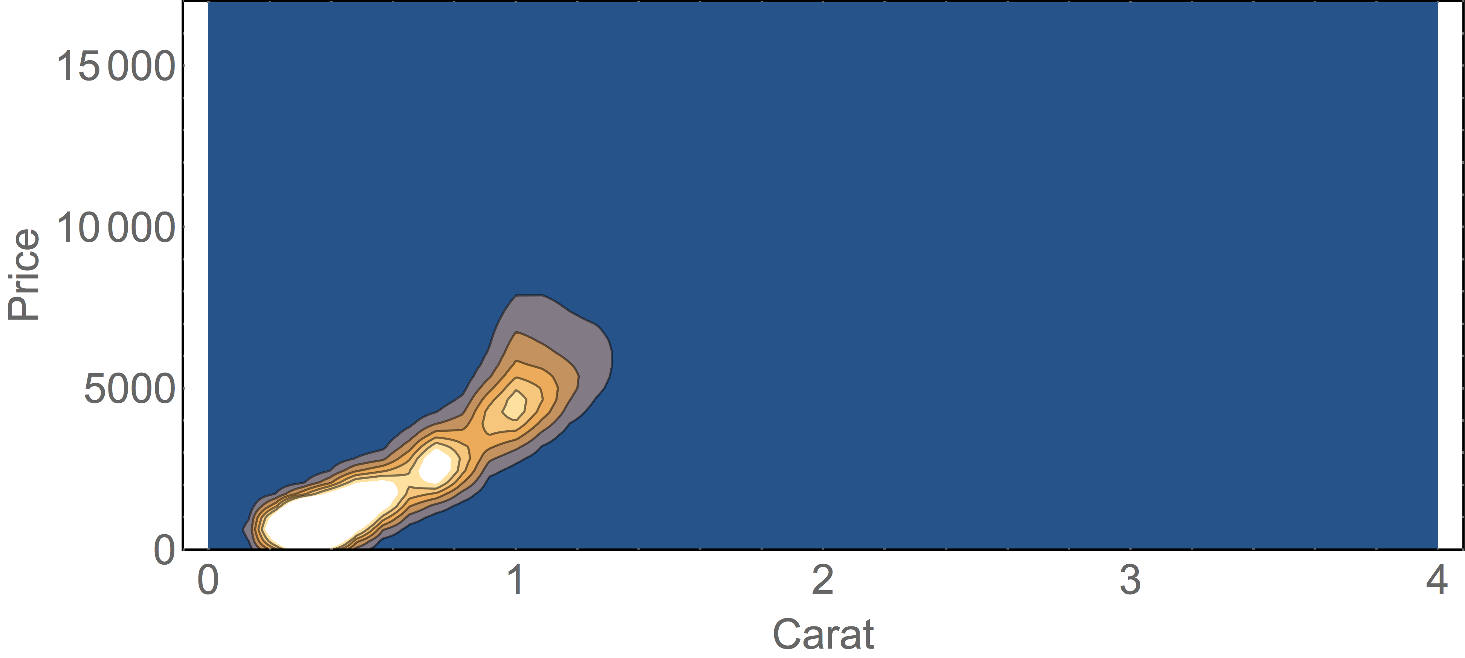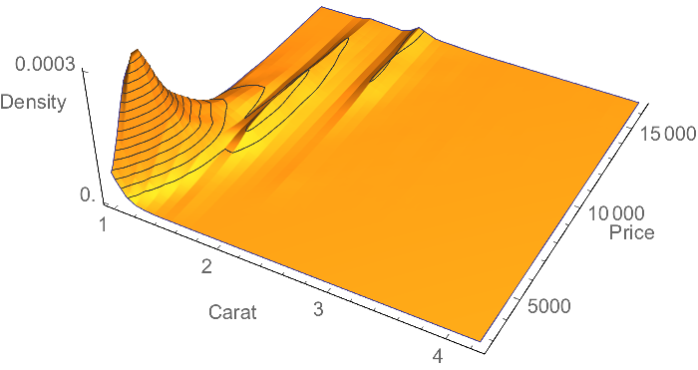

Figure 16. A three-dimensional 2d KDE and its associated contour plot.

**4.2 Discrete-Continuous Graphics**

At the end of Section 3.2 you may have found yourself asking, “What about boxplots?” They look at a single (typically continuous) variable, why were they not discussed?

Boxplots were not previously discussed because they are primarily used to explore interactions between a discrete variable and a continuous one. In practice, if only one continuous variable is under consideration, histograms or KDEs are generally far superior as they better communicate the fullness of the distribution.

*Teaching Tip: I typically teach numerical descriptives (means, standard deviations, etc.) after graphical ones. Since boxplots require percentiles, which are numerical descriptives, I tend to divide my discussion on graphical descriptives into two chunks: boxplots and violin plots after numerical descriptives, and everything else before.*

Consider the relationship between clarity and price. Naturally, as a diamond’s clarity increases, we would expect its value to similarly increase. The naïve way to investigate this relationship is to use the idea of a scatterplot; this is Figure 17.

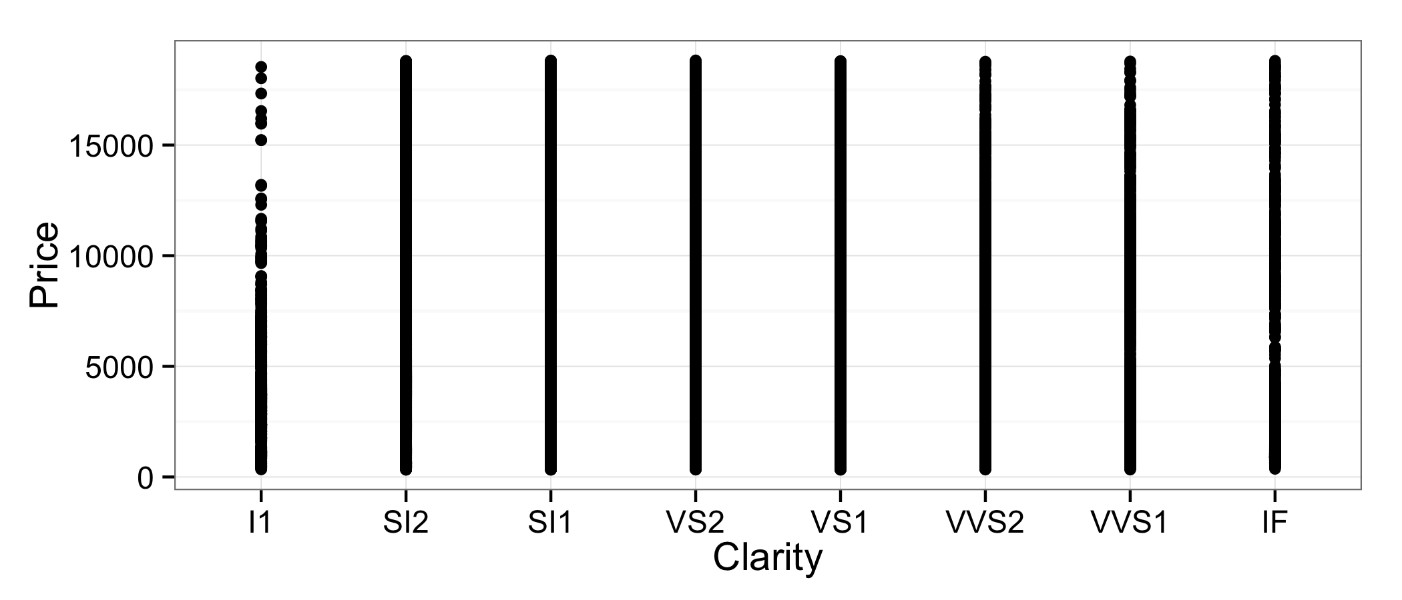

Figure 17. The scatterplot of price vs. clarity.

Figure 17 is a hopelessly useless graphic. With so much data, the overplotting swamps the visual completely, so that even if there were a strong association between clarity and price, we would not be able to see it. Jittering and alpha blending can help here, too; see Figure 18.

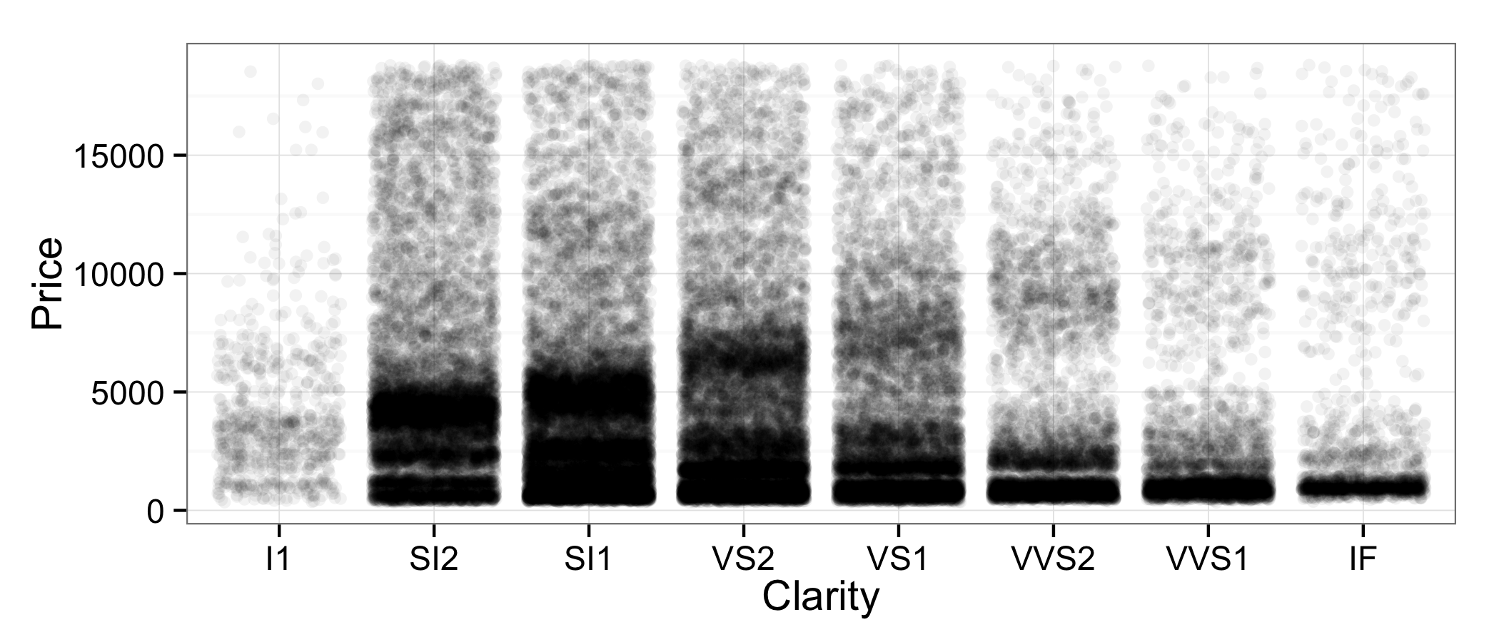

Figure 18. Jittered and alpha blended version of Figure 17 (opaque = 20 points).

Unfortunately, Figure 18 doesn’t resolve the problem either; overplotting is still drastic, and we can’t get any good feel for where the middles of the distributions are due to the extreme overplotting. Looking closer, there do appear to be clumps in each clarity category; we’ll come back to these in later discussions.

Boxplots are the standard way to get around this problem. The boxplot associated with this problem is in Figure 19. The associated violin plot, a close relative of the boxplot created by flipping over a KDE, is contained in the same figure.

The first look at Figure 19 should make you pause. Moving left to right across the ordered levels of clarity, the diamonds become *clearer*. Why, then, do they appear to cost less? Would it be correct to conclude that, as diamonds become clearer, they cost less? Surely something is wrong. The answer lies in the subtleties displayed in Figure 18, and we’ll see how to visualize them in Section 5. For now, we take a detour to understand the association between two other variables in the dataset, clarityand cut.



Figure 19. The price-clarity boxplot and violin plot.

**4.3 Discrete-Discrete Graphics**

Another interesting consideration is the relationship between clarity and cut. Since cut is, at least to some extent, at the discretion of the cutter, it would make sense that the better a diamond is in terms of clarity, the more effort the diamond cutter will put into the diamond, and consequently the better the cut of the diamond. But how are we to visualize the relationship between two discrete variables? Therer are only 8×5 = 40 possible combinations of clarity and cut!

One place that we may think to start is with a scatter plot. As already observed, there will be extreme overplotting between the two, so we start with jittering, alpha blending, and resizing to produce Figure 20.

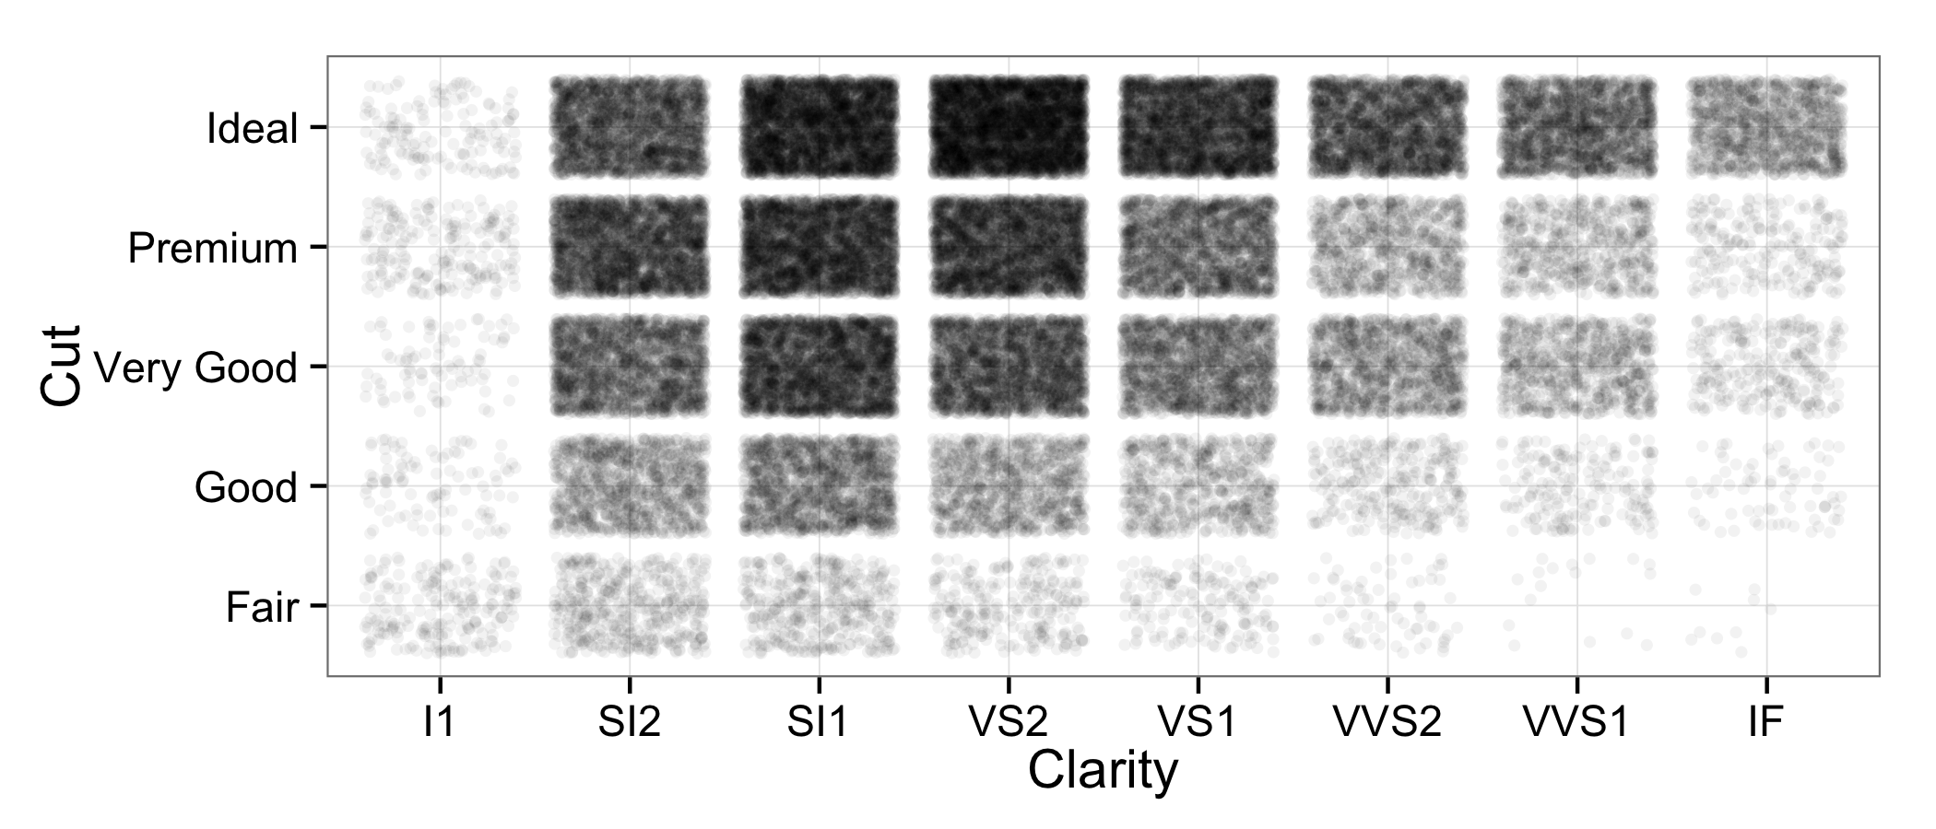

Figure 20. The cut-clarity scatterplot, jittered and alpha blended (20 = opaque).

While Figure 20 *looks* interesting, and does in fact tell us *something* about the joint distribution of the two variables, it doesn’t clearly clue us in to what we want to know: does clarity have an effect on cut? To answer this question, we really need some more ideas.

Consider Internally Flawless (IF) diamonds in Figure 20. By far the darkest rectangle is comprised of ideal cut diamonds, and that seems to resonate with our expectations: better diamonds, better cuts. However, notice that the interpretation is in terms of shades of black *relative to other rectangles in that column*. That is to say, the interesting thing to consider is *the proportion of IF diamonds* that are Fair, Good, Very Good, Premium and Ideal, and how that proportion change across categories. We want to understand the conditional distributions of the diamonds’ cuts, given their clarity. How can we visualize those distributions?

One idea is to try colored bar charts. Figure 21 presents two such attempts encountered frequently in practice: the dodged and stacked bar charts.

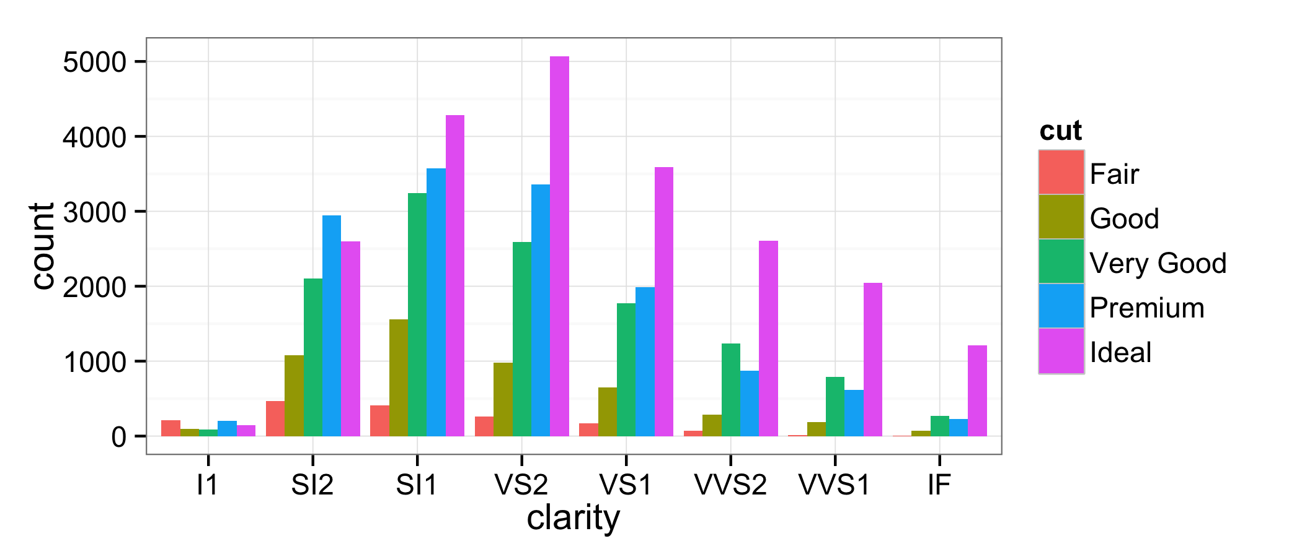

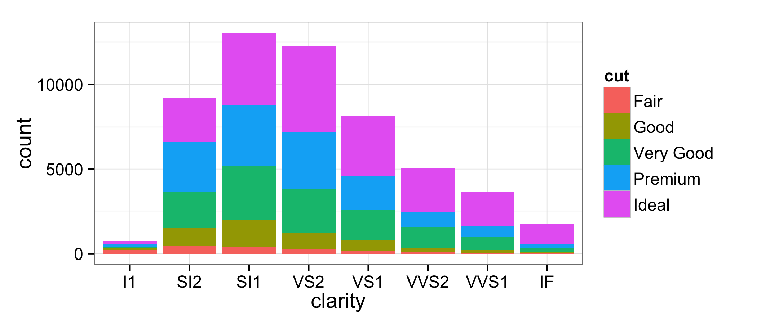

Figure 21. Dodged (top) and stacked (bottom) bar charts of clarity by cut.

Graphics like those in Figure 21 can be very insightful. I find them helpful in different ways: the dodged bar chart is a little better at communicating within-groups variability, and the stacked bar chart a little better at communicating between-groups variability (e.g. most diamonds are SI1). It can be difficult, however, to comment on within-groups proportions across groups, though. For example: given a SI1 and a VS2 diamond, which is more likely to be Premium cut? Stacked bar charts rescaled to show relative frequency communicate this idea quite well; see Figure 22.

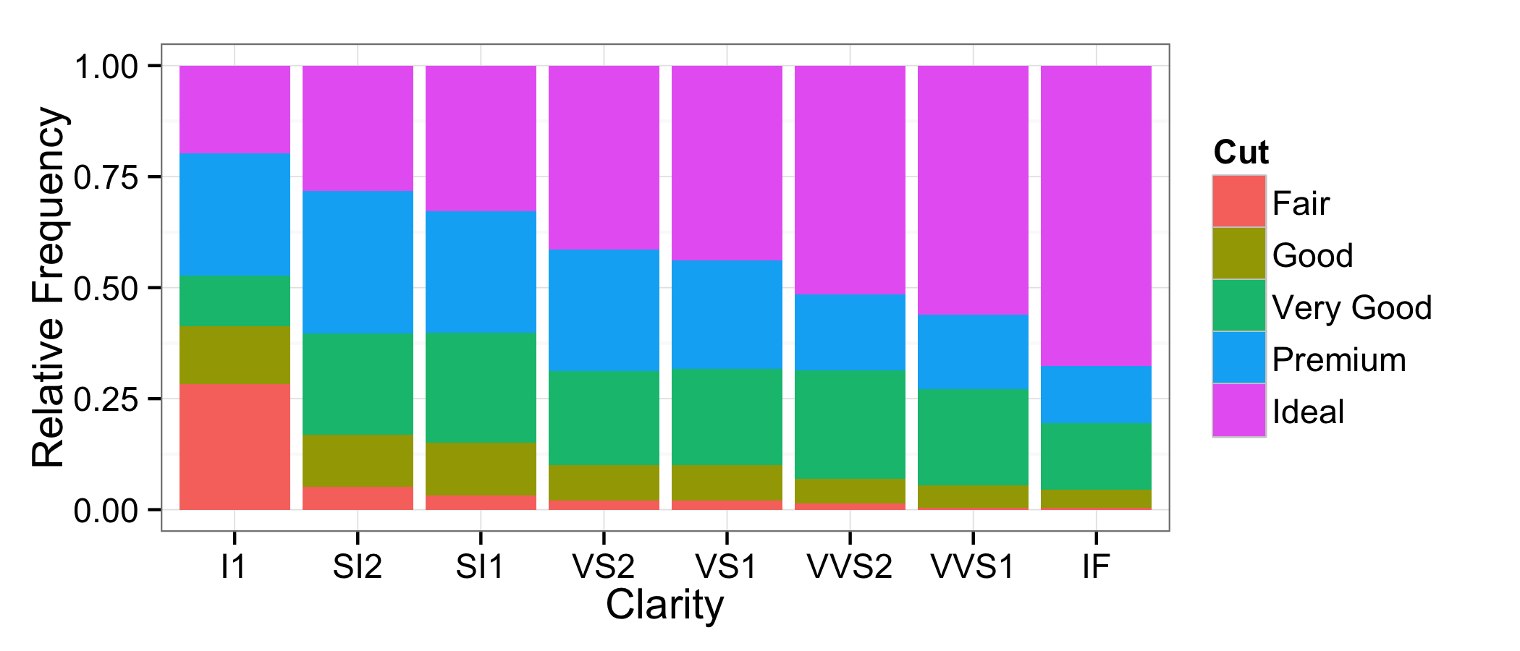

Figure 22. Stacked bar chart based on within-group relative frequency.

The drawback to the kind of graphic in Figure 22, however, is that it completely obscures between-group variability. There is no way to tell, for example, whether SI1 diamonds are more prevalent or IF diamonds are more prevalent. This problem is overcome with the mosaic plot. Mosaic plots exploit the fact that the widths of the bars in Figure 22 do not communicate meaning by giving them meaning: scaling them by their prevalence in the overall dataset. The mosaic plot corresponding to Figure 22 is presented in Figure 23.

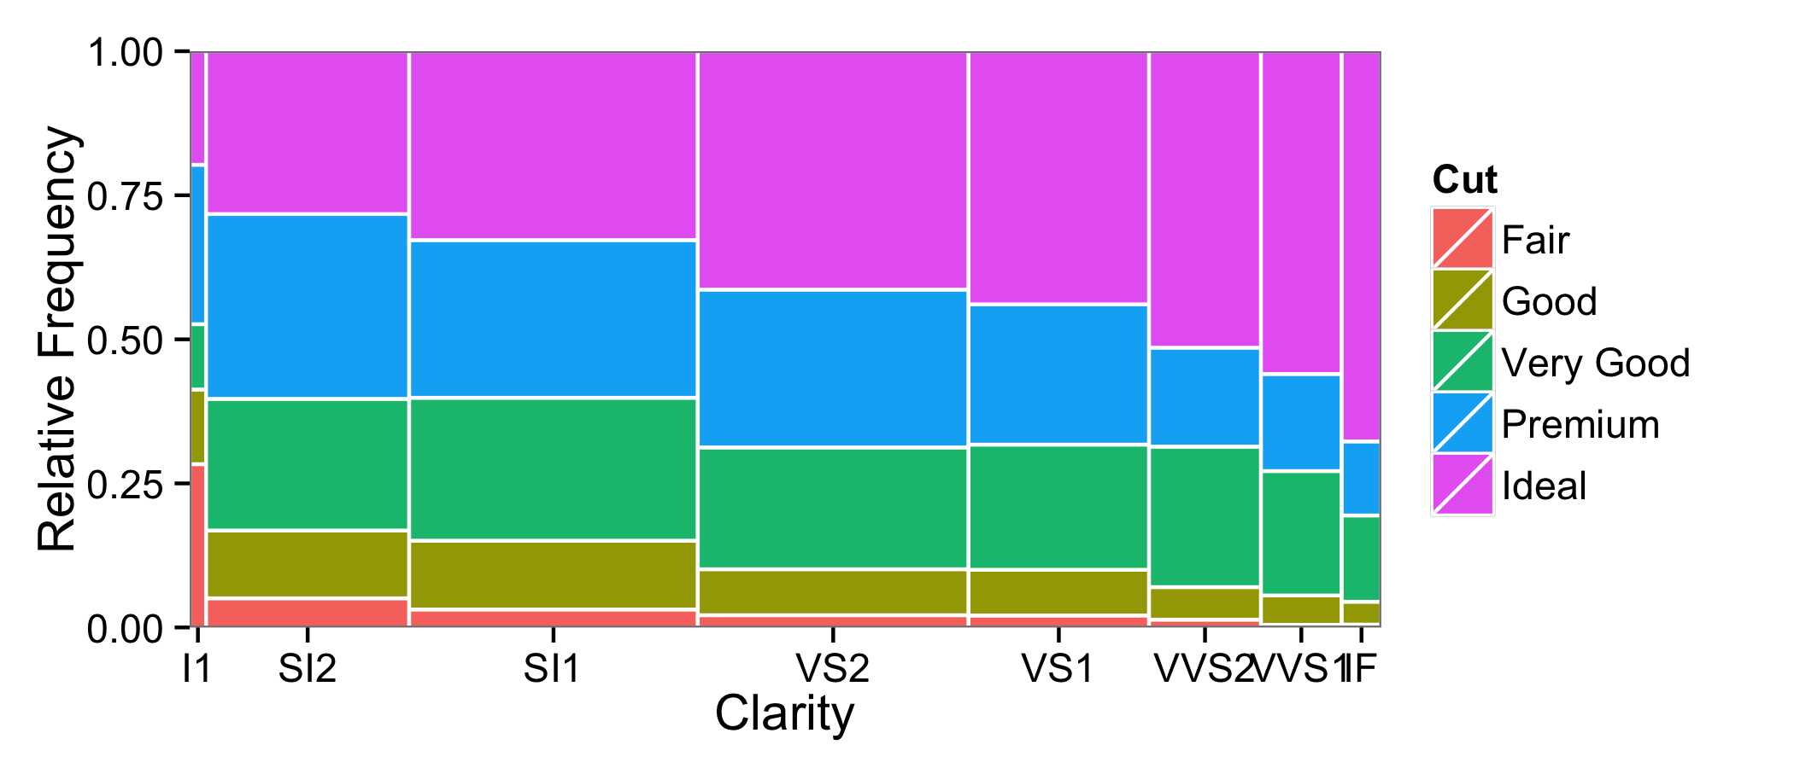

Figure . Mosaic plot of cut vs. clarity.

Mosaic plots have another nice interpretation: the area covered by each tile relative to the entire plot represents the proportion of those kinds of diamonds among the entire collection of diamonds, since joint probabilities are products of conditional and marginal probabilities.

**5. Analyzing Several Variables Together**

sdfasd

**6. Conclusions**

In this article, I have introduced a novel pedagogical module, freely available online, that can help teachers motivate and animate statistical concepts. Due to the complexity of the module, it is accompanied by a simplified module for student use. Both are created using the revolutionary .cdf technology of Wolfram Research, which affords developers a high-powered framework for interactive mathematical and statistical computation that is translated into a fluid user experience. It is hoped that the module will be helpful to instructors at both the high school and college levels for the conceptual understanding of probability distributions.

**7. Acknowledgements**

It is my pleasure to thank the Editor, Dr. Everson, as well as an anonymous Associate Editor and reviewers for several helpful comments that have made this work stronger.

**References**

Aliaga, M., Cobb, G., Cuff, C., Garfield, J., Gould, R., Lock, R., Moore, T., Rossman, A., Stephenson, B., Utts, J., Velleman, P., and Witmer, J. (2005), *Guidelines for assessment and instruction in statistics education: College report*. The American Statistical Association. Available at <http://www.amstat.org/education/gaise/>.

Kahle, D. (2014), “Animating Statistics: A New Kind of Applet for Exploring Probability Distributions,” *Journal of Statistics Education*, 22(2), 1–21.

Scott, D. (1992), *Multivariate Density Estimation: Theory, Practice, and Visualization*, New York, NY: John Wiley & Sons, Inc.

Tufte, E. (2001), *The Visual Display of Quantitative Information*, 2nd Edition, Cheshire, CT, Graphics Press.

Wickham, H. (2009), *ggplot2: Elegant Graphics for Data Analysis*, New York, NY: Springer.

Wickham, H. (2013), “Bin-summarise-smooth: A framework for visualising large data.” Technical report. Available at <http://vita.had.co.nz/papers/bigvis.pdf>.

David J. Kahle, Ph.D.

Assistant Professor of Statistical Science

Department of Statistical Science

Baylor University

One Bear Place #97140

Waco, Texas, USA 76798

(254) 710-6102

[david_kahle@baylor.edu](mailto:david_kahle@baylor.edu)

1. While the difference is in fact significant (*p* < .01) and seems plausible, if one digs deeper into this phenomenon, he will find that the difference is not quite as pronounced, and perhaps not even as certain, as it may appear on the surface. I disregard these possibilities, however, as they don’t really matter and detract from the moral of the story.